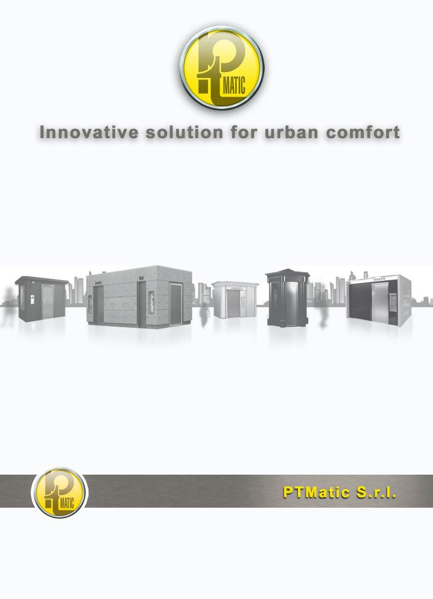
TECHNICAL DESCRIPTION
SELF CLEANING AUTOMATIC TOILET
Mod. T WATER

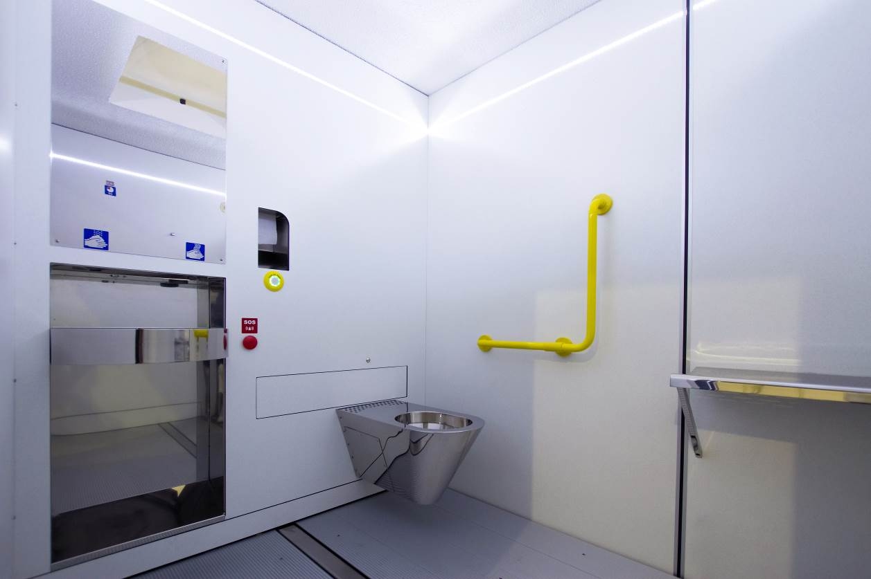

TWATER H
Self cleaning automatic interiors toilet suitable for disable people.

FEATURES
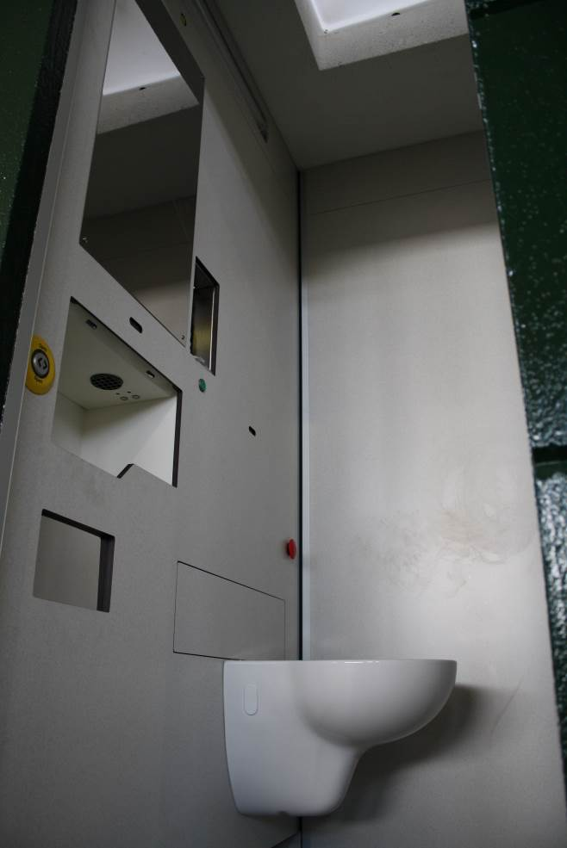
T Water 10-15 unisex room

The prefabricated toilets series T WATER are units designed to be installed both inside new buildings and existing ones: it entirely replaces the traditional toilet room, avoiding the construction of tiled walls, access door, systems, etc, providing all automatic washing and cleaning equipment which are typical in the P.T. Matic production.

Sizes, in the T WATER 10-15 model, of the user room (m. 1,00-1,20 X 1,20- 1,50) and the accessories arrangement allow the easy use by people without physical problems.
The construction system can make many versions and dimensions to satisfy the different floor plan requirements.

In the T WATER H and 19 model the user room dimensions and accessories arrangements allow the use by disable people on wheelchair.
.

The main feature of the toilets is the automatic washing with disinfection of:

- the inside of the WC bowl through thin water layer during its use;
- the inside of the bowl (expulsion) and exterior at the end of use with the sitting surface drying;
- walls, up to 0.8 m of height in correspondence with the WC bowl;
- floor.
- The whole user room, with full disinfection night system, All inside toilet is disinfected with exclusively cleaning cycle by fog atomizer, during the 1-hour stop night. DCN (on request).
Safety devices avoid the start of cleaning operations while the user is inside the toilet.

The unit is supplied in the standard version as described and is fitted with a series of accessories (optional) upon request.
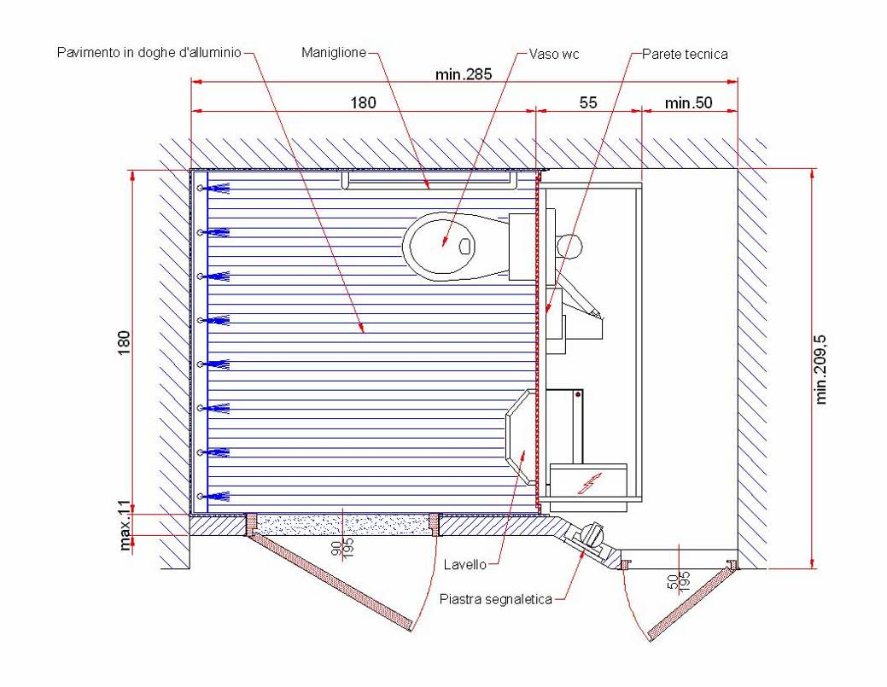

STRUCTURE
Stainless steel structure supporting the walls.
The walls are made of high pressure plastic sheet with double layer of melamine finishing, they can be divided and are detachable to facilitate transport and handling. The unit is re-assembled when it is being installed. Internal High Pressure Laminate (HPL) walls having panel of 12 mm width. The colour and features are warm and welcoming. The walls are fixed on a stainless steel structure. The interior surfaces are graffiti and fly-posted proof.
The technical vain has a width of 42 cm and it contains all electro mechanical devices.
Floor made up with anti-slip aluminium profile with frame of stainless steel. The has a reduced width in order to reduce the entry step height into the installation on the plane slab.
AUTOMATIC closing door with electrical door opener. Door in frame of aluminium and HPL panel.
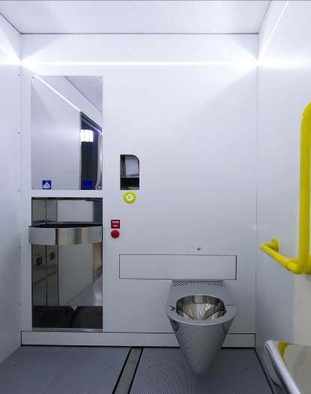
Inside room
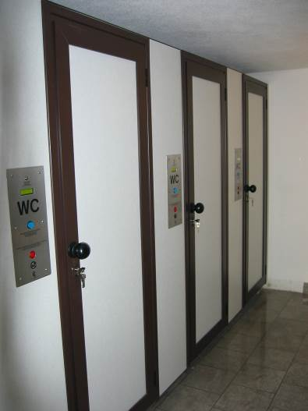
External features

EQUIPMENTS
Hanging baked clay bowl.
Automatic internal lighting with wall lamp.
External manual dispenser for toilet paper Jumbo roll type.
External vandal resistant panel fitted with “FREE/BUSY”, OUT OF SERVICE” warning lights. The basic version is fitted with push button for free use. LCD display on the sheet with instructions in 4 languages and indication of the out of service causes.
Detection of person presence through infra red.
Emergency button located near the bowl which causes the door opening (even with no power supply) and activates the emergency optical and acoustical warnings.
Device for the washing and disinfection bowl and for the automatic drying of the sitting surface. Automatic devices for cleaning after every use.
Tank for water additivated with disinfectant having the “lack of water” control.
Disinfectant liquid tank having the “minimum level” control and dosing pump.
Water pressure pump of the water circuit of the various washings.
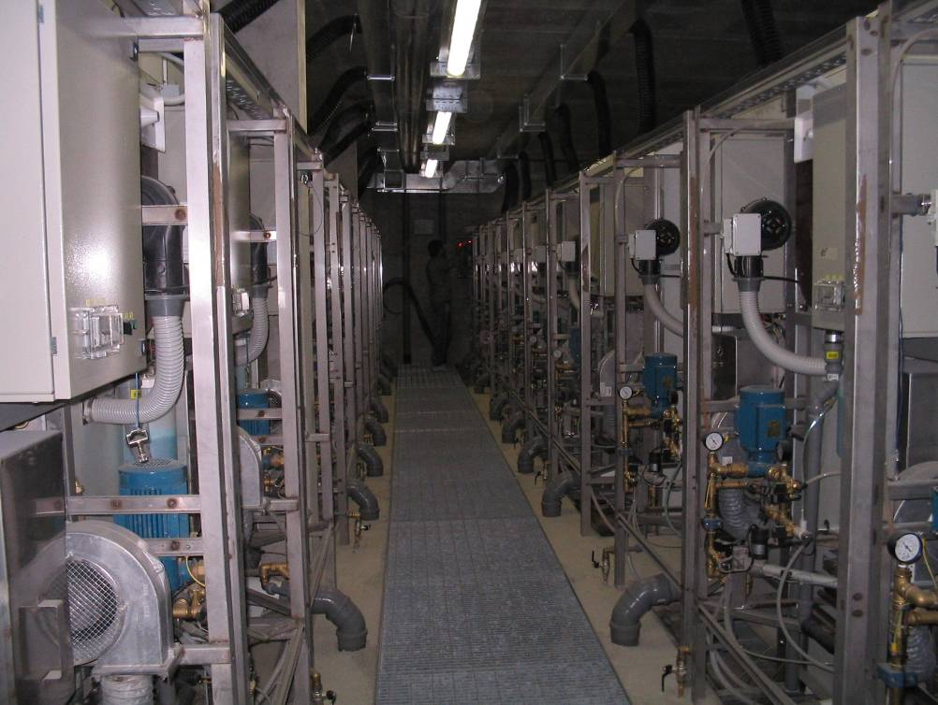
Technical room solution with 20 unisex units

OPTIONAL
ACWxx | Automatic sliding door, electrical sliding stainless steel door fitted with sandwich panel with double stainless steel plate and insulation foam. Door open and close automatically.
ACW05 | Multicoin-operated equipment fitted with coin return device for door opening control, coin-collecting box ad usage cycle counter
ACW20 | Washbasin group with automatic water dispenser
ACW21 | Hand dryer group with warm air dispenser.
ACW22 | Automatic toilet paper dispenser in pre set quantity. set in to wall which replaces the external manual toilet paper dispenser.
ACW25 | HPL ceiling having a reinforcement profile and vandal resistant lighting on the ceiling which replaces the standard wall lamp.
ACW26 | Air recycling fan

USE CYCLE
With the activation of the button placed on the external plate (free use) or with the introduction of the currency in the coin box (payment on use) is automatically activated:
The lightening system of the toilet;
The opening of the door;
The available time count down;
The "occupied" signal on the coin box;
The increment of an unit of the counter;
The sonorous spread vocal signal (if demanded);
The distribution of the veil in the bowl;
The fan for air re-cycle.
The automatic dispensers of water, soap, air, and of the toilet paper.
From the moment in which the cabin it comes occupied, the control device, verified the weight on the footrest, it enters in occupied state and come qualified following operazion:
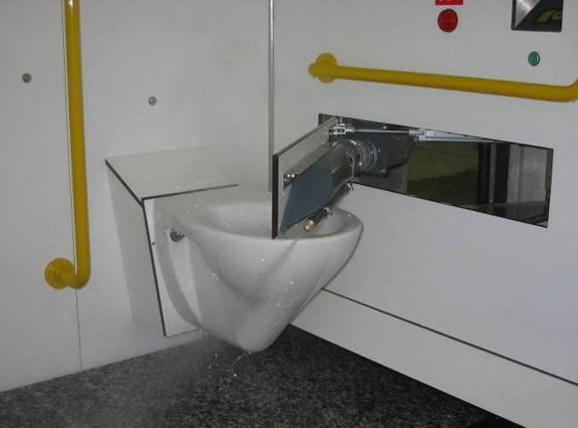WC washing and drying system

The unit stays enlightened;
The door is closed;
The toilet closes automatically;
Control and security systems are activated;
Vengono attivati i sistemi di sicurezza e di controllo;
Available time count down starts.
Once the use is done the user presses the door handle to exit and he activates the automatic open. The door stays open until the user isn’t outside. In the case that the user or another person would re-enter before the closing of the door, the door will reopen and the emergency signal (optical and acoustical) starts.
When the toilet is vacant these processes start:
Door closing;
Extinction of the lighting system lamp;
Extinction of the lighting system lamp;
Switch off of music diffusion,
Switch off of the security systems;
Switch off of automatic dispenser;
Consent for the beginning of the washing cycle and disinfection of the toilette;
Reset of use time.

AS the washing cycle is done , the efficiency of all devices is checked before let the unit available.

T. WATER Technical sheet

Electric
Electrical connection without winter heating | 220V F.N.3KW
Current max scattered | 0.03A
Electrical and signal voltage | 5, 12, 24V
Minimal section feeling cables | 2,5 mm2

Plumbing
Tube fresh water | ∅ ¾”
Minimal pressur of water link | 1,5 atm.
Tube drainage dirty water | ∅ 110 mm.
Tube drainage floor | ∅ 75 mm.

Tanks capability
Water tank | l. 60
Disinfectant tank | l. 10
Disinfectant tank (battery installations) | litri 25
Liquid soap tank | l. 3

Consumptions (without heating)
Water consumption (every cycle) | lt.33
Disinfectant consumption (every cycle) | cc.20
Electricity consumption (every cycla) | 80-100 W
Pre set toilet paper quantity | Fino a 99
Pre set toilet paper autonomy | 400 pieces

Cycles times
Length of washing, disinfection and drying system | 60 seconds

T WATER DRAWINGS

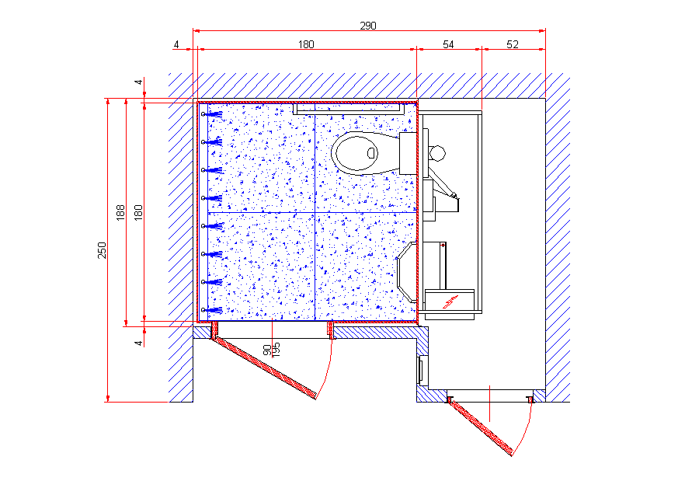
T Water H

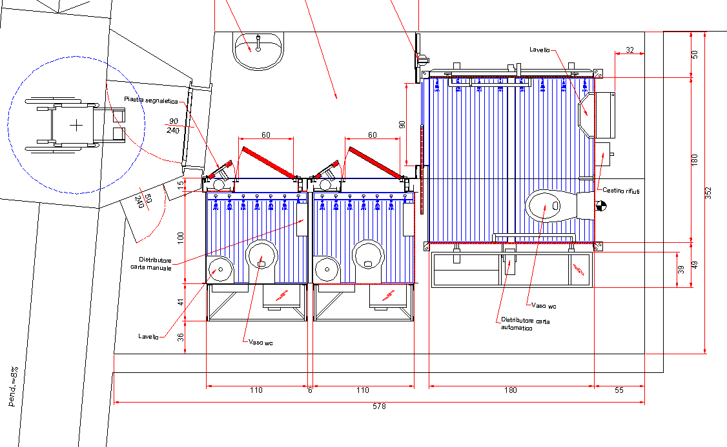

T box h and 2 twater 11

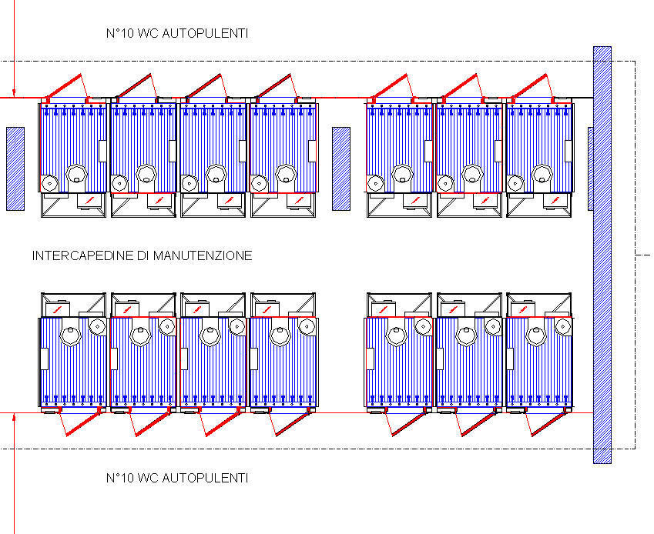
T water 15
T water 10

PORTFOLIO T WATER

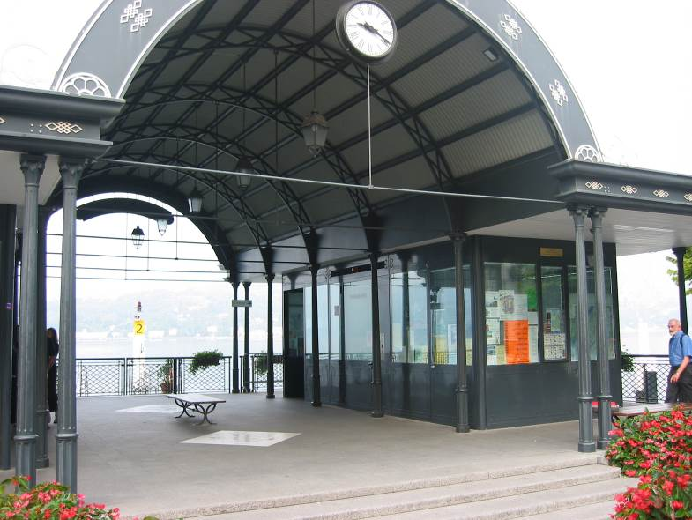 Bellagio

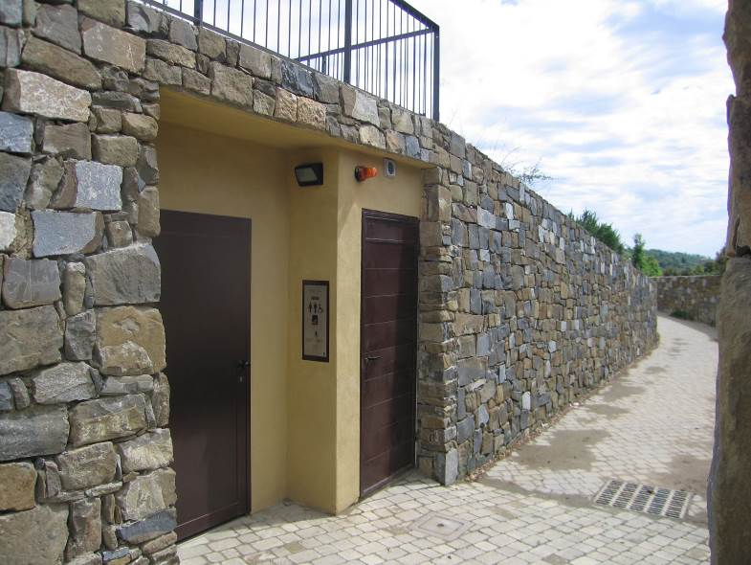 Montalcino
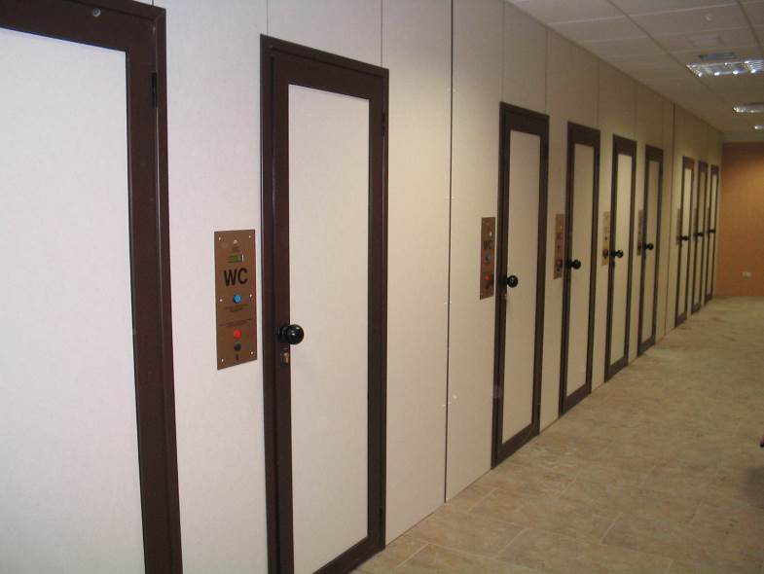 Livigno

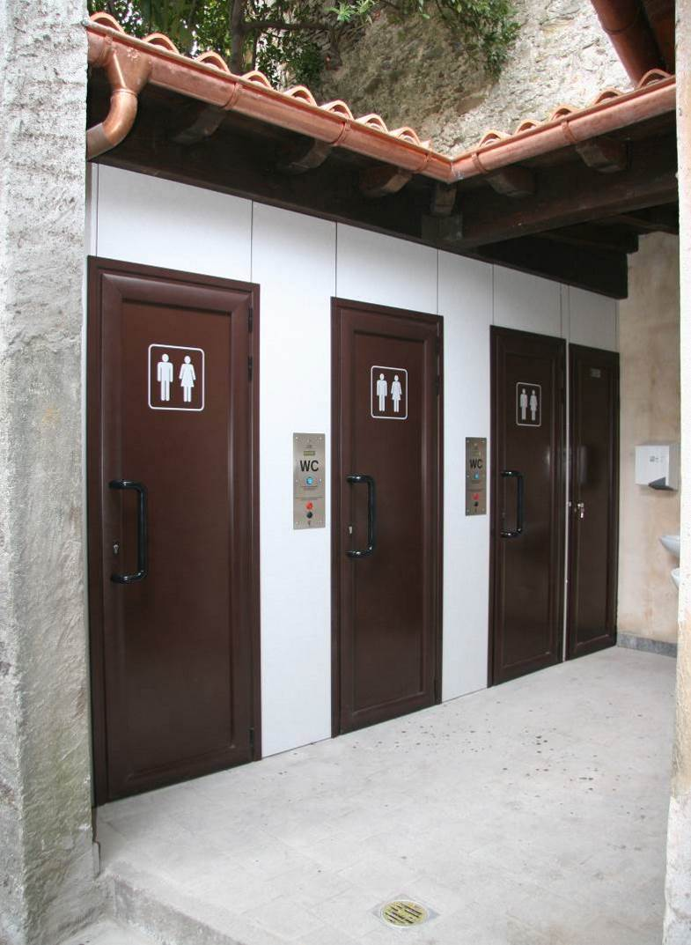 Isola Bella, Stresa.

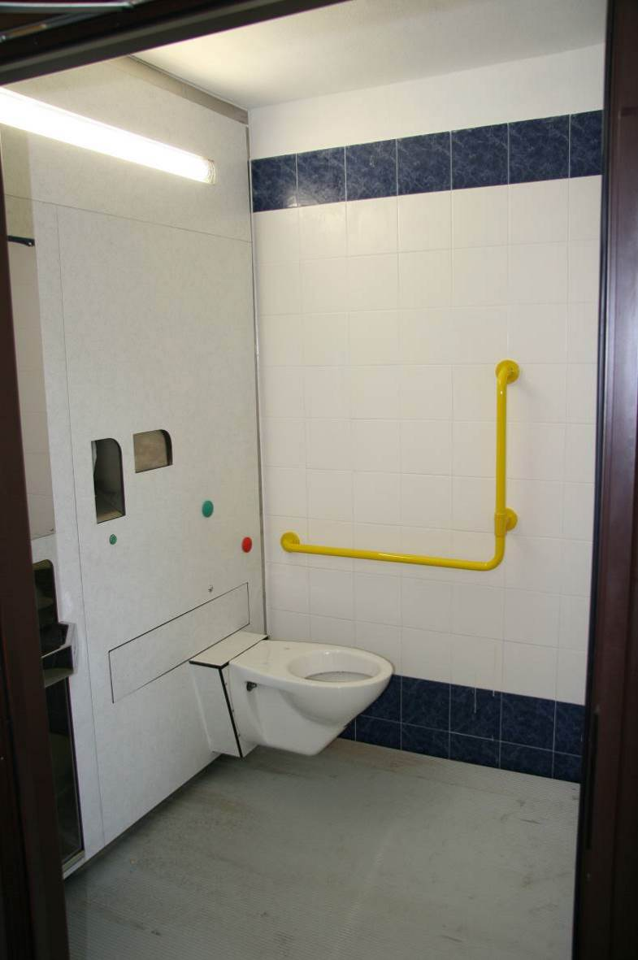 Isole Borromee, Stresa.

