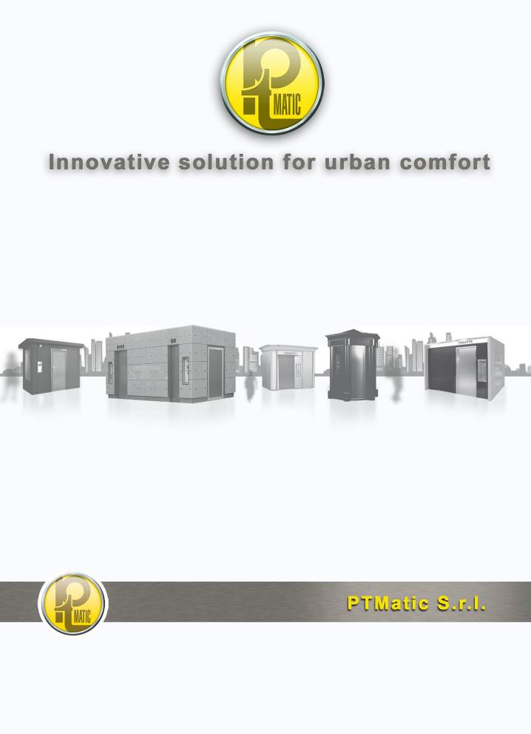
TECHNICAL DESCRIPTION
SELF CLEANING FULL AUTOMATIC TOILET
Mod. T BOX

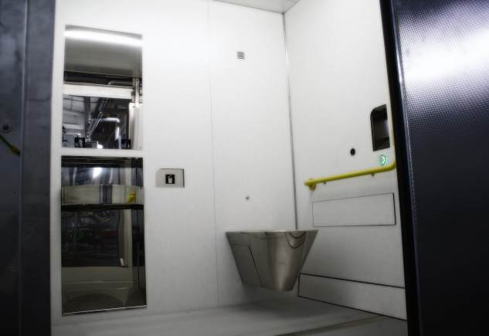
T Box H
Self cleaning full automatic toilet for internal also suitable for people with physical problems.

FEATURES
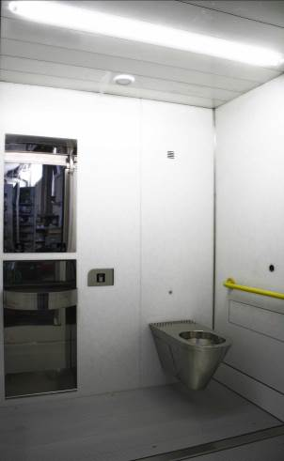
TBox 15 internal

The prefabricated toilets series TBox are units designed to be installed both inside new buildings and existing ones: they entirely replace the traditional toilet room, avoiding the construction of tiled walls, access door, systems, etc., providing all automatic washing and cleaning equipment which are typical in the P.T. Matic production.

The TBox 15 model has sizes of cm 150 x 110, the construction system can make many versions to satisfy the different floor plan requirements.

The unit can be divided and this facilitates the insertion of the TBox unit, both single and in battery, in the service rooms.

In the TBox H model sizes of the user room and the arrangement of the accessories allow the use by people on wheelchair and are perfectly in conformity with the requirements of the Ministerial Decree no. 236 dated 14 June 1989 confirmed by the Presidential Decree no. 503 dated 24 July 1996.

The main feature of the toilets is the automatic washing with disinfection of:

- the inside of the WC bowl through thin water layer during its use;
- the inside of the bowl (expulsion) and exterior at the end of use with the sitting surface drying;
- walls, up to 0.8 m of height in correspondence with the WC bowl;
- washbasin.
- floor.
- The whole user room, with full disinfection night system, All inside toilet is disinfected with exclusively cleaning cycle by fog atomizer, during the 1-hour stop night. DCN (on request).
Safety devices avoid the start of washing operations if the user is inside the toilet.
The unit is supplied in the standard version as described and is fitted with a series of accessories (optional) upon request.

STRUCTURE
Stainless steel structure supporting the walls.
The walls panels are made of high pressure laminates panels (HPL), having a thickness of 12 mm, can be divided and are detachable to facilitate transport and handling. The unit is re-assembled when it is being installed. Walls are fixed on a stainless steel structure. Panel are fireproof, antivandal and antibacterial no joint allow to clean all surface.
The walls finishing is welcoming, light internal colours white based with grey dots patter, lamp allow to create a comfortable and wide space.
Floor made up with anti-slip aluminium profile on stainless steel frame.
AUTOMATIC opening and closing door, retractable sliding, having a stainless steel sectional frame, externally coated with stainless steel fingerprint. Thermal acoustical insulation is performed through expanded polyurethane 4 cm width.
The emergency button with ergonomic dimensions is placed near the door and it ensures the automatic opening also in case of lack of electric power , or the manual opening in case of breakdown of the pneumatic device.

EQUIPMENTS
Hanging baked clay bowl;
Stainless steel washbasin built into the wall with safety device anti-syringe, the washbasin dumping is placed in the technical cubicle, possible objects are conveyed in a proper container.

In-built stainless steel waste bin

In-built stainless steel wash basin with “no touch” dispensers for water, soap and air

Indicator of available time

Automatic internal lighting. Emergency internal lighting in case of electrical black out;
Automatic water, soap and hot air dispensers for hand drying, controlled by infrared sensors controlled by the microprocessor which are excited by the presence of the user hands. Soap supply is pre-set to avoid waste.
Automatic toilet paper dispenser made of stainless steel Jumbo-Roll type, in a pre-set quantity.
External vandal resistant panel fitted with a display with warning lights “VACANT/OCCUPIED/ OUT OF ORDER” . The multi-coin operated equipment, set on the external signalling panel, allows to vary easily the amount.
Display LCD with instructions, to use the toilet and indication of the cause of possible “Out of Work” in four languages. Therefore, the system provides precise diagnostics for all maintenance interventions. Signs on this panel explain the function of the APT.
Stainless steel mirror, clothes hook made of stainless steel, handles for people having physical problems.
Stainless steel trash bin built into the wall fitted with fire-breaking door, accessible only fron the technical cubicle.
Baby change table (on demand).
Emergency button located near the bowl which causes the door opening (even in case of power failure) and activates emergency optical and acoustical alarms. The safety button located on the right of door having ergonomic shape and size, ensures the automatic opening even with power failure, or the manual opening in case of pneumatic system failure.
Time warning system fitted with digital display and emergency signal indicating the remaining three minutes. Time can be easily changed from 2 to 30 minutes.
Emergency external optical and acoustical warning device
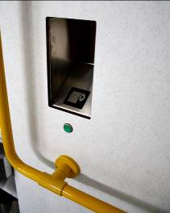
Automatic toilet paper dispenser
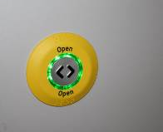 VistaPT® Door open button

FEATURES
Tank for water added with disinfectant fitted with “no water” control. Water reserve always ensures the washing after use, before putting the toilet “Out of work” for no water.
Disinfectant liquid tank fitted with “low level” control and dosing pump.
Pump of the water circuit of the various washings.
Washing and sanitation device of the bowl outside and for the automatic sitting surface drying. Equipment for the complete bowl washing.
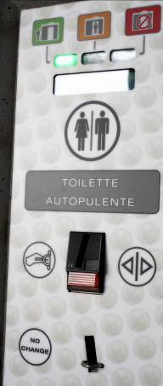
Coin machine

particolare gettoniera con display
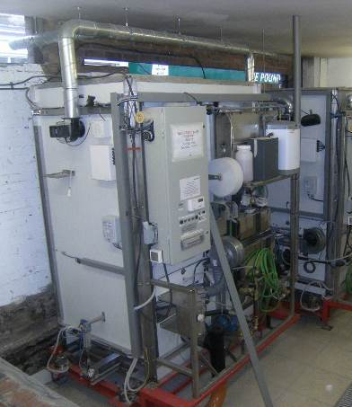
Technical area

Vano tecnico

Lava;–Tergipavimento®, automatic device for washing, drying and the removal of objects and waste from the smooth serizzo granite floor, through mobile “floor wiper” device (our Patent no. MI 2005 A001873). This device removes even larger items like soft drink cans, 1,5 litres plastic water bottles, news papers ect. During the cleaning the floor is undergone a cleaning from detergent and disinfectant cycle and mechanical cleaning with brushes and is dried after the cleaning. The cleaning is after every use and takes care of larger items like soft drink cans, news papers, plastic water bottles, napkins etc.
Full disinfection night system DCN. The only device that disinfected All inside toilet with exclusively cleaning cycle by fog atomizer, during the 1 hour stop night.
Transfer pneumatic unit for the automatic door opening and closure and the activation of the washing and disinfecting system of the bowl.
Detection of person presence through electronic weight detectors (load cells), with safety program for minimum weigh (children safety) and maximum weight (two person control). Weight sensing system (load cells) does not allow the floor to be cleaned if the weight detectors indicate that the automatic public is still occupied. The complete cleaning cycle does not take more than 60 seconds.
Electromechanical cycle counter which cannot be reset on the electrical panel, electronic which can be displayed.
Use timer of the unit, fitted with the automatic opening at the pre-set time end, through optical/acoustical warning.
Protection and control electrical panel, fitted with differential switch idn 0.03 A and microprocessor for the computerized management of all operations of user presence and toilet washing. The microprocessor allows to change: operating time, unit usage price, time at disposal for the user; disinfectant

NOTE

The working data of the toilet can be varied, on demand, by using a personalized circuit of memory (for example included the frequency of walls and floor washing for possible reduction of water use).
The unit can be fitted also without one or two walls ( the frontal and/or the left lateral one), in the case you want to use the building existing walls. (For information ask for Technical walls and completion walls for APT).
In the case that one or more walls of the unit couldn’t be accessible from outside because of the impossibility to create appropriate technical cubicle, one or more walls can be opened from the inside of the user cubicle. (For information ask for Technical walls and completion walls for APT).

OPTIONAL
ACB01 | Winter environment heating for temperatures up to – 5°C
ACB05 | Multicoin-operated equipment fitted with coin return device for door opening control, coin-collecting box ad usage cycle counter..
ACB06 | Recognition magnetic card reader.
ACB07 | Unit remote control through transmission of “Out of Work” warning by GSM line. The unit communicates via a GSM line with the Central Unit (with PC unit) or GSM mobile phones (Pc unit and mobile phones are not provided by P.T.MATIC) service and maintenance staff of any service, fault condition or low level consumables. At the Central Unit Centre the staff uses PC-based graphic software to remotely view status and alarm data.
ACB08 | Lava;–Tergipavimento®, automatic device for washing, drying and the removal of objects and wastes from the floor, through mobile “floor wiper” device.
ACH15 | Full disinfection night system DCN, All inside toilet is disinfected with exclusively cleaning cycle by fog atomizer, during the 1 hour stop night.
ACB11 | Hot water boiler.
ACB13 | Stainless steel hanging bowl which replaces the standard baked clay bowl.
ACB14 | Minimum weight check (for children safety)
ACB20 | HPL ceiling Tbox H having a reinforcement profile and vandal resistant lighting on the ceiling which replaces the standard wall lamp.
ACB21 | HPL wall panel Tbox

USE CYCLE
With the activation of the button placed on the external plate (free use) or with the introduction of the currency in the coin box (payment on use) is automatically activated:
The lightening system of the toilet;
The opening of the door;
The available time count down;
The "occupied" signal on the coin box;
The increment of an unit of the counter;
The sonorous spread vocal signal (if demanded);
The distribution of the veil in the bowl;
The fan for air re-cycle.
The automatic dispensers of water, soap, air, and of the toilet paper.
From the moment in which the cabin it comes occupied, the control device, verified the weight on the footrest, it enters in occupied state and come qualified following operazion:
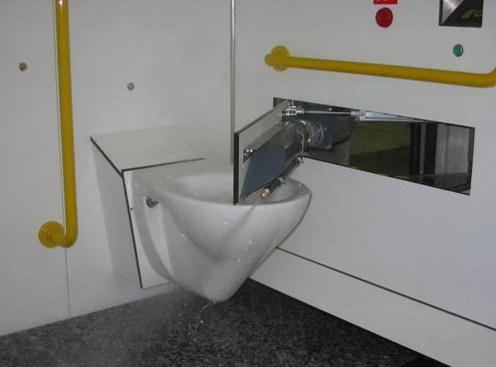WC washing and drying system
The unit stays enlightened;
The door is closed;
The toilet closes automatically;
Control and security systems are activated;
Vengono attivati i sistemi di sicurezza e di controllo;
Available time count down starts.
Once the use is done the user presses the door handle to exit and he activates the automatic open. The door stays open until the user isn’t outside. In the case that the user or another person would re-enter before the closing of the door, the door will reopen and the emergency signal (optical and acoustical) starts.
When the toilet is vacant these processes start:
Door closing;
Extinction of the lighting system lamp;
Extinction of the lighting system lamp;
Switch off of music diffusion,
Switch off of the security systems;
Switch off of automatic dispenser;
Consent for the beginning of the washing cycle and disinfection of the toilet;
Reset of use time.
AS the washing cycle is done , the efficiency of all devices is checked before let the unit available.
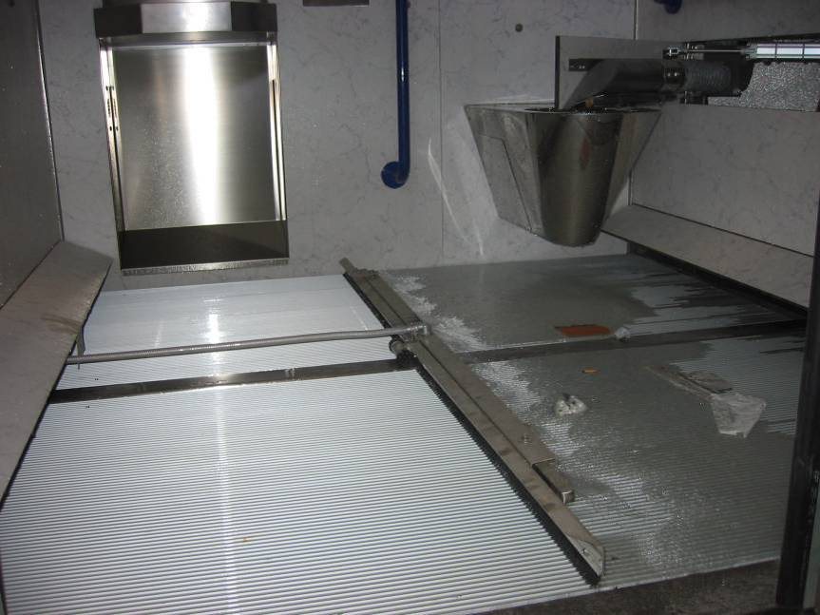Washing system Lavatergipavimento

T. BOX Technical sheet

Electric
Electrical connection without winter heating | 220V F.N.3KW
Current max scattered | 0.03A
Electrical and signal voltage | 5, 12, 24V
Minimal section feeling cables | 2,5 mm2

Plumbing
Tube fresh water | ∅ ¾”
Minimal pressur of water link | 1,5 atm.
Tube drainage dirty water | ∅ 110 mm.
Tube drainage floor | ∅ 75 mm.

Tanks capability
Water tank | l. 60
Disinfectant tank | l. 10
Disinfectant tank (battery installations) | litri 25
Liquid soap tank | l. 3

Consumptions (without heating)
Water consumption (every cycle) | lt.33
Water consumption with Tergipavimento
Disinfectant consumption (every cycle) | cc.20
Electricity consumption (every cycla) | 80-100 W
Pre set toilet paper quantity | Fino a 99
Pre set toilet paper autonomy | 400 pieces

Cycles times
Length of washing, disinfection and drying system | 60 seconds

T BOX PLAN
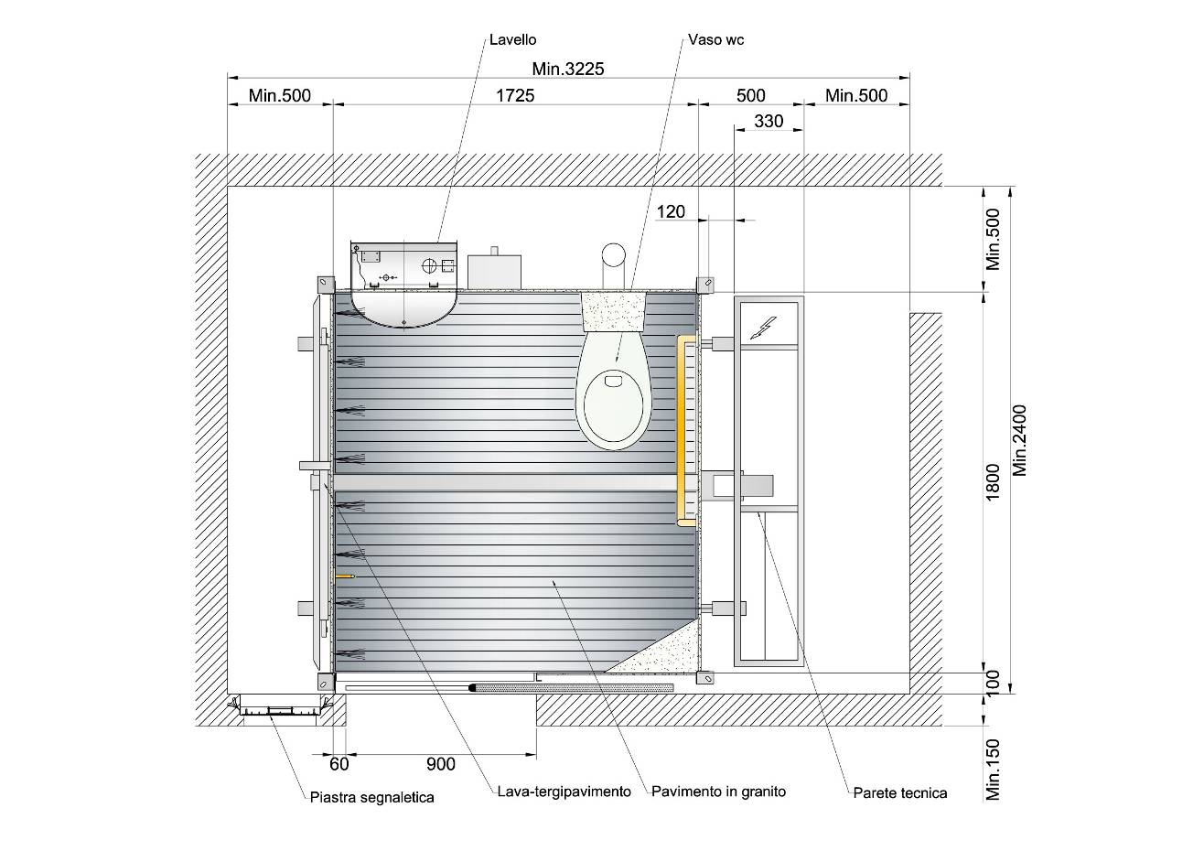
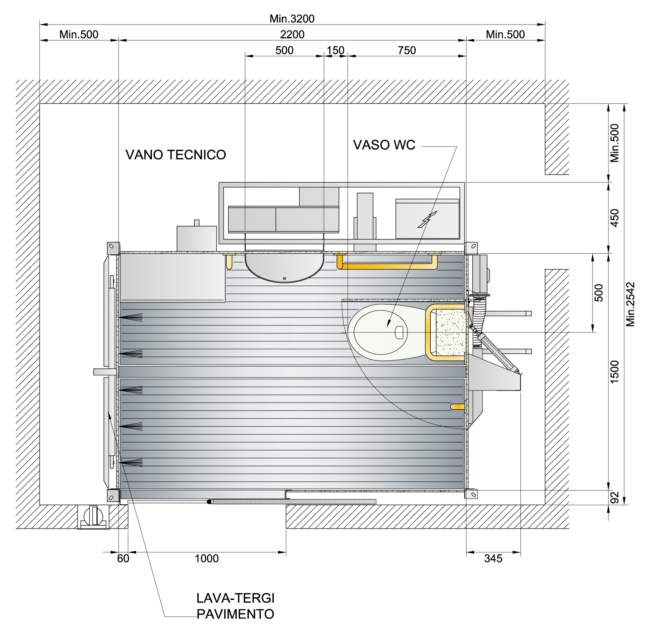
TBOX H

TBOX22

PORTFOLIO T BOX

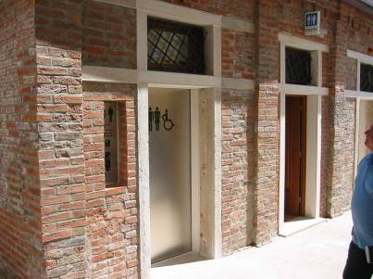 Chioggia-venice

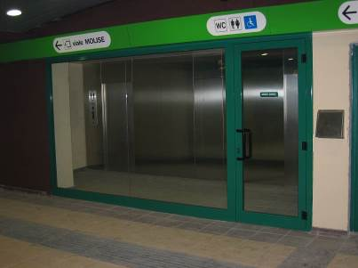 Milan, Subway MM
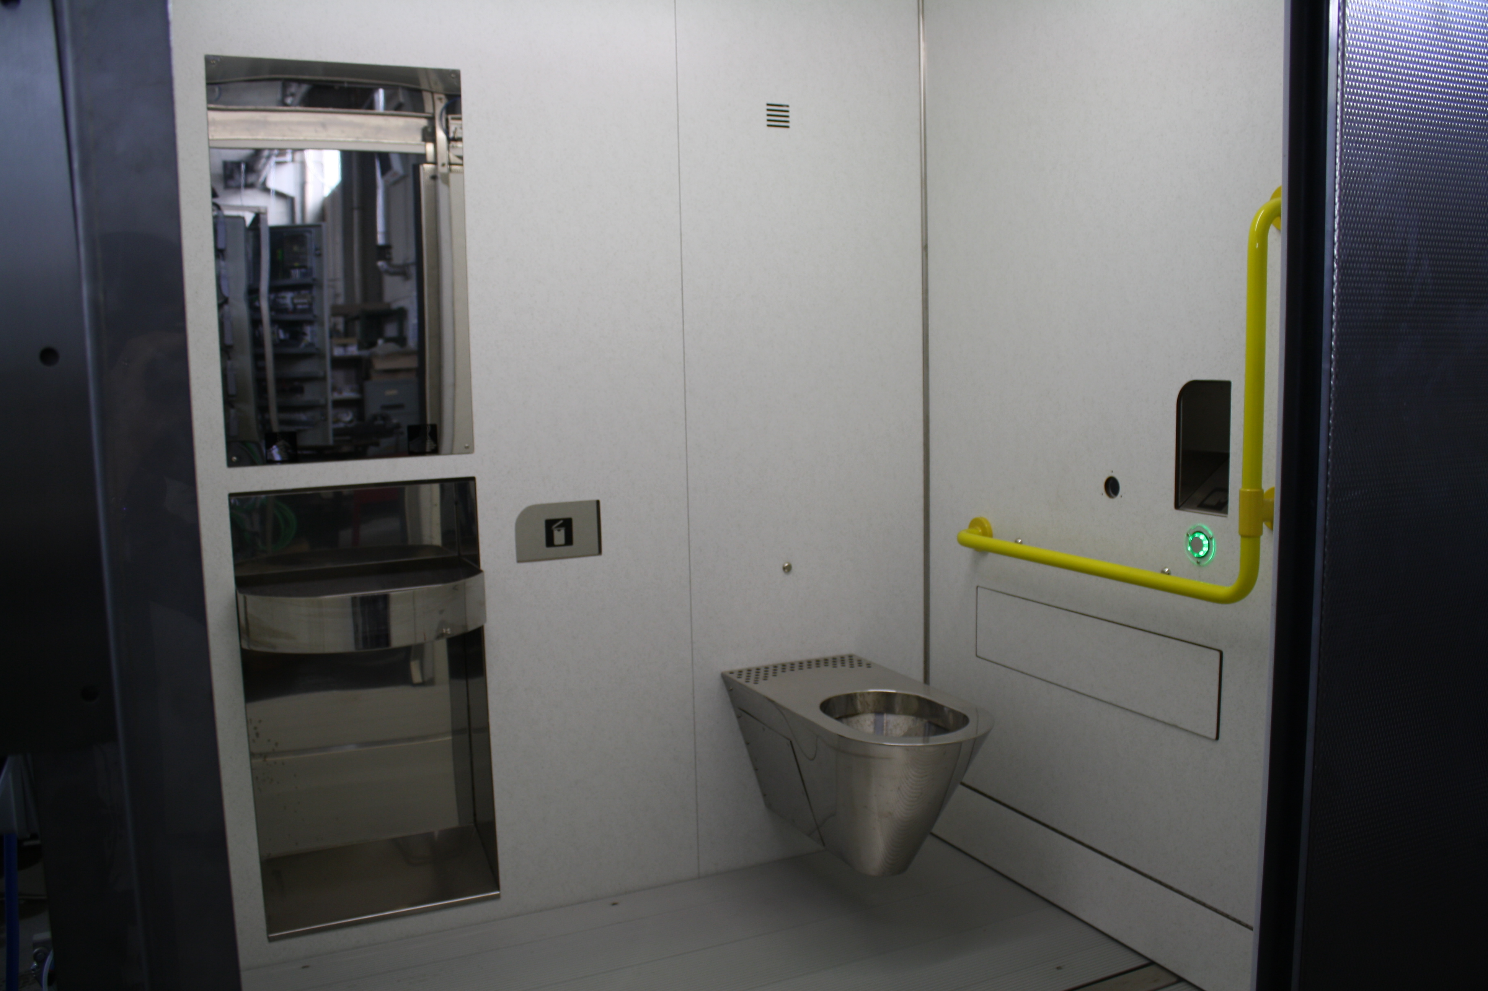Rome, Subway “Metro C”

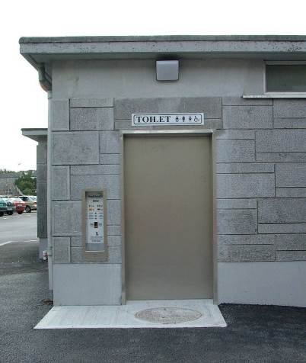 Ballinasloe, UK

